**Day 4**

**What to do?**

Build linear regression and logistic regression models using neural networks. Compare how they are performing with scikit learn implementation.

**Linear Regression:**

We know neural networks are all depended on activation functions. Using activation functions, we can also implement a linear regression, since linear regression is synonymous to single perceptron 1-layer neural network. (I did not know that till now!) Because the output is single linear line, the network would contain only one neuron.

However, to see how linear regression performs using NN, I will compare 1-layer NN with scikit implementation.

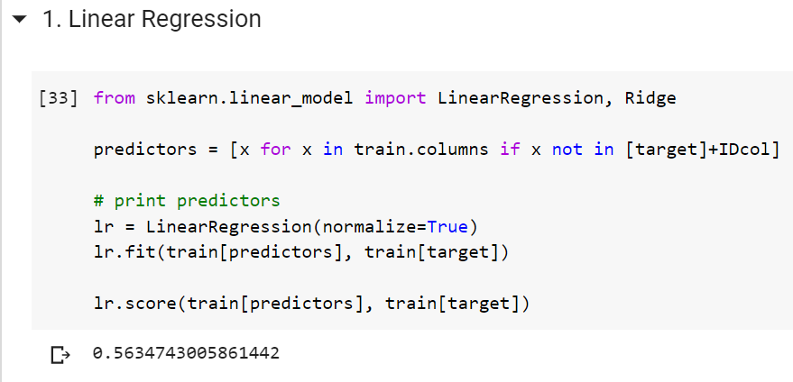

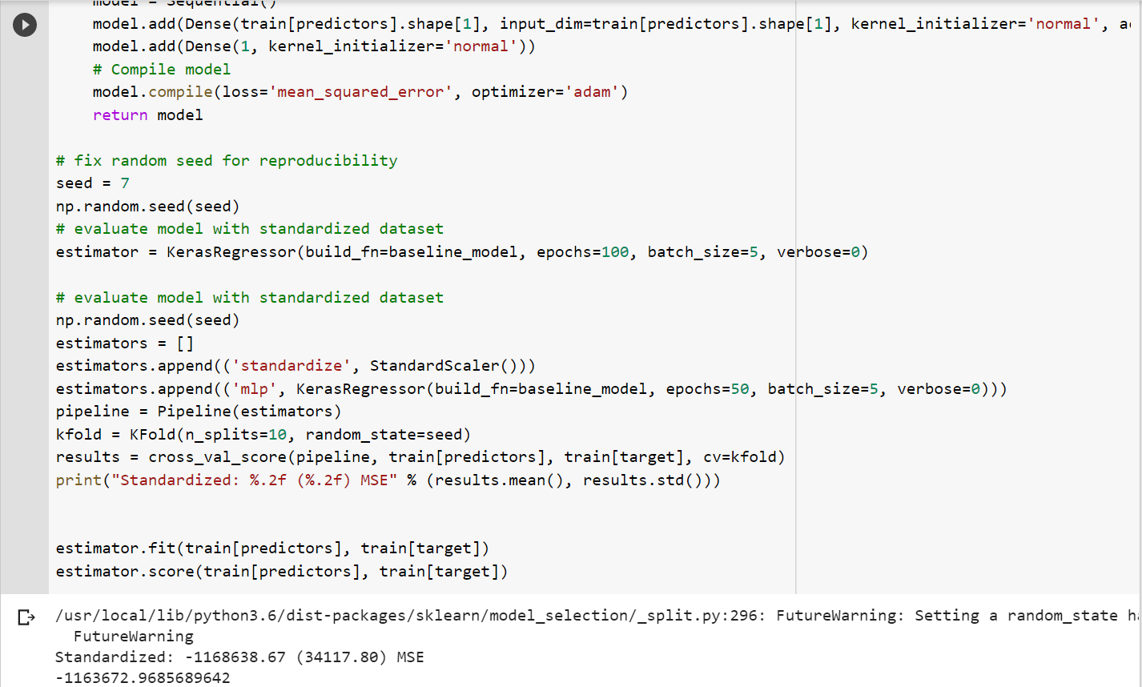

**Logistic Regression:**

As linear regression is a single layer neural network, logistic regression is all about logarithmic – logits in neural networks. While “linear” is the activation function for neural network linear regression, “sigmoid” is the activation function for neural network logistic regression.